## Biomecanica

### Yang et al 2020

Yang, X., Lim, Z., Jung, H., Hong, Y., Zhang, M., Park, D., & You, H. (2020). Estimation of finite finger joint centers of rotation using 3D hand skeleton motions reconstructed from CT scans. *Applied Sciences*, *10*(24), 9129.

* “Digital human hand models have been widely used in ergonomic product design and evaluation”
* “the assumption that the hand is a rigid linkage system,”
* “metacarpophalangeal (MCP), proximal interphalangeal (PIP), and distal interphalangeal (DIP) joints “

### Chen chen et al 2011

Chen Chen, F., Favetto, A., Mousavi, M., Ambrosio, E., Appendino, S., Manfredi, D., ... & Bona, B. (2011, July). Human Hand: Kinematics, Statics, and Dynamics. In *41st International Conference on Environmental Systems* (p. 5249).

* ~~“The human hand is an extremely complex system due to its large number of degrees of freedom (DoF) within a significantly reduced space. Moreover, it is required for most of the tasks performed by humans.”~~
* “Sections 4 to 6 present data about forces, torque, velocities and power”
* “The human hand is composed of…”

### Kargov et al 2004

Kargov, A., Pylatiuk, C., Martin, J., Schulz, S., & Döderlein, L. (2004). A comparison of the grip force distribution in natural hands and in prosthetic hands. *Disability and Rehabilitation*, *26*(12), 705-711.

* “Comparison of grip in natural and prosthetic hands …”

### Fourie 2017

Fourie, R., & Stopforth, R. (2017). *The mechanical design of a biologically inspired prosthetic hand, the touch hand 3* (pp. 38-43). IEEE.

* “1.1.1.8 Finger and hand antropometry data: …”

## RCM

### Diagrama Descripción generada automáticamenteZhang et al 2019, 2014

Zhang, F., Lin, L., Yang, L., & Fu, Y. (2019). Design of an active and passive control system of hand exoskeleton for rehabilitation. *Applied Sciences*, *9*(11), 2291.

* “the SPRM [symmetric pinion and rack mechanism ] and the parallel mechanism, which can realize the telecentric motion around the joint center”

### Imagen que contiene persona, foto, mano, secadora Descripción generada automáticamenteHernández-Santos et al, 2021

* “Table 1 presents a comparative review of exoskeletons developed for hand rehabilitation. Not all of the exoskeletons can be applied effectively to daily life, e.g., only a few can

be used alone without a large drive device. Some are too complex, bulky, and unwearable,

with many active DOF, or are too expensive for home and personal use.”

* Table 1: buena comparación

### Biouras et al, 2020

* “One of the most crucial dimensional characteristics is the thickness in the lateral areas of the fingers that is coaxial to the finger joints”
* “a wearer that has thinner and longer fingers will have more space between the fingers, which will permit the mounting of an exoskeleton”
* “[RCM] has the considerable advantage of saving a lot of space between the fingers, an essential factor to take into account when designing the orthotic shell of the exoskeleton fingers”
* “underactuated redundant linkage (URL) structure as seen in Figure 2c.The size of the mechanism is considerably larger”
* “[URL] this design does not have the precise control of each phalange individually”
* [URL] bfewer actuators and can provide a more natural movement of the wearer’s hand due to its underactuated mechanism and the compliance of the biological hand
* “two types of cable transmission are used, namely pulley-cable transmission [39] and Bowden cable transmission [40].”
* “exoskeleton segments corresponding to the finger phalanges do not need to be controlled individually [36]. A better solution is to rely on the body’s natural compliance while actuating the exoskeleton.”

### Sandison et al, 2020 (handsome)

### Diez et al, 2017

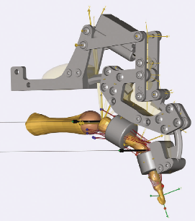

### Batezzato et al 2014

* “to maintain the weight and complexity as low as possible, an only two-phalange mechanism is considered: it is a quite common solution for exoskeletons [4,18–20]”

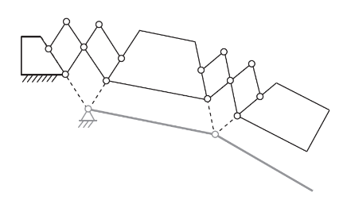

### Enriquez et al 2014

* Tabla 1: rango de mvto de los dedos

### Fontana et al 2013, 2009

### Fang et al 2009

* “placing an exoskeleton mechanism over an operator's finger is more reasonable than beside an operator's finger. To mimic the motion of the operator’s finger, the rotation centers of exoskeleton mechanism should coincide with the rotation centers of the operator's fingers to avoid the mechanical interference”

### Wang et al 2009

* Fig. 1. Biomechanical model of index finger

### Nakawara et al 2005

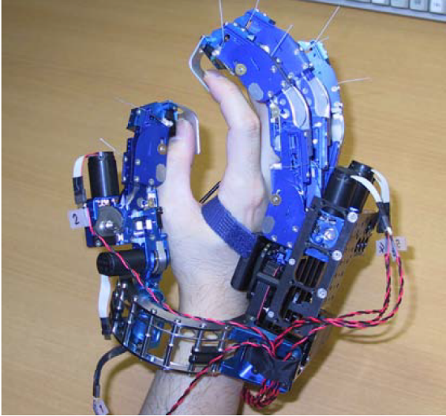

Shields et al 1997

* Each joint uses a four-bar mechanism to rotate about an instant center that corresponds to the instant center of the proximal phalanx with respect to ground and the middle phalanx with respect to the proximal phalanx”
* “the parallelogram structure of the mechanism the instant centers remain fixed relative to the ground link in each joint. The design of each joint mechanism was governed by having the appropriate instant centers coincide with the centers of rotation of the wearers’ fingers.”
* The kinematic coefficient relating the proximal exoskeleton link to the input link has a constant value of 1 for all three exoskeleton fingers.

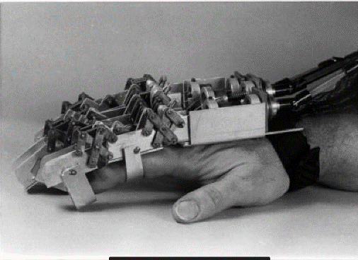

## Estados del Arte

### Noronha et al 2021

Noronha, B., & Accoto, D. (2021). Exoskeletal devices for hand assistance and rehabilitation: A comprehensive analysis of state-of-the-art technologies. *IEEE Transactions on Medical Robotics and Bionics*, *3*(2), 525-538.

* ~~“However, people who have lost the movement of their hands or ability to properly control them cannot or have difficulty in performing such Activities of Daily Living (ADLs) [1]. The loss of hand function is often associated to neurological or muskuloskeletal conditions (e.g., traumatic injuries or muscular disorders)”~~
* ~~Efforts have been made and are continuously increasing in providing rehabilitation and/or daily assistance to people that have a medical condition which diminishes their hand function ability.~~
* ~~“namely with the development of soft and hybrid devices”~~
* ~~In terms of daily life assistance, the use of robotic devices, namely exoskeletons, could greatly improve~~
* the independence of their users *Adapted Technology Readiness Levels (aTRL)* Fig. 10. Results of the literature review for the criterion aTRL

* ~~“The vast majority of devices actuate the fingers together with the thumb (72%) due to the nature of the function of the hand”~~
* ~~“Underactuated devices are often the preferred alternative in terms of actuation level (82%) + preferred alternative especially when developing devices for daily assistance”~~
* ~~“[fully actuated mechanisms] are used almost exclusively for rehabilitation”~~
* ~~“fully actuated devices are generally not suitable for assistance in the performance of ADLs”~~
* “~~Underactuated devices has been increasing over the years, whereas the opposite has happened for fully actuated ones”~~
* “Rigid devices have been the main option + easily modelled behavior ~~+ most do not properly account for a misalignment between the robot’s and the user’s joints~~”
* “This is due to their [soft devices] soft properties that intrinsically solve the joint misalignment problema”
* ~~“This [bowden cables] makes it difficult to model the output force of the actuator, requiring sensors at the distal end which further increase the bulkiness of the wearable component of the system~~
* ~~“[linkage transmisions] comes at the cost of increasing the weight of the wearable part of the device, given that the actuation system is typically stored on the hand itself [76] or on the arm [64], also resulting in poorer wearability of the device + far less used when compared with flexible transmissions”~~
* ~~“[fluidic transmisions] has observed an increase in preference over the last years due to the rise in popularity in soft robotics”~~
* ~~“[coupled dofs] easily controllable than other types of underactuated mechanisms [82], [83]. However, they can make the device very bulky~~
* “greatest increase over the years is the cable on glove”
* ~~“[cable in glove] An independent DOF sub-type allows for highly precise control of the fingers, yet it typically requires an actuator for each segment, which can make the device bulky~~
* ~~“[constrained sliding requiring extra care to prevent hyperextension”~~
* “[EMG] are commonly used due to their easy implementation and feature extraction
* “surface electrodes are used, which limits the resolution of the signals and increases the susceptibility to recording artefacts”
* ~~“only 11 also presented an evaluation of the performance of the motion intention detection algorithm + The average success rate when considering only implicit signals was 83%”~~
* ~~“most devices are at development and laboratory testing phases”~~
* ~~“only 6 being on the market + “only such devices [underactuated] have reached commercialization phase.”~~
* ~~“high comfort, which is a defining trait in user acceptability”~~
* ~~“investigators working on hand exoskeletons usually focus their efforts on new transmissions”~~
* “kinematic signals seems to be still limited. This could be due to these signals requiring good motor skills to be preserved by the user, which is generally not the case with impaired users
* “dynamic-based intention detection is very easy to implement by using force sensors on the fingertips”
* ~~“most devices are meant for rehabilitation (84%), there being twice as much as ones meant for assistance (42%)”~~
* ~~“the greatest challenge is in the development of wearable robots that can be used for daily assistance rather tan being limited to clinical settings”~~
* ~~“Most devices are not able to aid with multiple types of grasping which is fundamental to a healthy use of the hand in daily life”~~
* ~~“The assistance of thumb abduction/adduction, resulting in its opposition, is often ignored”~~
* ~~“The ability of the brain to imagine a motion, also known as motor imagery, has been shown to be highly useful in detecting motion intention, while at the same time stimulating neurorehabilitation + few devices integrate EEG sensing + focus is usually brought to the mechanical characteristics of the system first”~~

### Rosen et al 2019

Rosen, J. (Ed.). (2019). *Wearable robotics: Systems and applications*. Academic Press.

## Requerimientos

### Boser et al 2020

Boser, Q. A., Dawson, M. R., Schofield, J. S., Dziwenko, G. Y., & Hebert, J. S. (2020). Defining the design requirements for an assistive powered hand exoskeleton: A pilot explorative interview study and case series. *Prosthetics and Orthotics International*, 0309364620963943.

* differences between participants exist and identifying a universal set of criteria applicable across individuals with impaired hand function is challenging
* [in EMG measurements] The software gain was adjusted for each participant to achieve maximum eparability of signals
* Clinicians and participants with hand impairment mostly agreed on expectations for a hand exoskeleton regarding important grasp patterns, grip strength, wear time, and acceptable weight. However, responses also revealed differences in desired requirements. Some participants were more tolerant of a slower, bulkier, or louder device, so long as it was helpful, while others indicated that they would not use such a device. Most participants had some experience with rehabilitation devices that may have influenced their responses.
* *Forearm EMG.* Of the movements examined, wrist flexión and extension consistently produced the most promising EMG signals
* wrist flexor muscle, the pattern of EMG activity was indistinguishable from wrist extensión
* Seven participants: 200 g would be manageable additional weight
* 5 × 5 × 3 cm3 block too bulky
* adjustable enough that individuals could try before buying
* Must be easy to clean; ideally waterproof
* Wear the device for 6 h to a full day expressed a desire for intuitive control strategies (controlling the device with their “mind”) and an aversion to simple strategies, such as a push button
* 10 N of pinch grip force may be a reasonable goal to aim
* flex sensor on the wrist and forearm surface EMG
* myoelectric control of a hand exoskeleton is feasible, although the best control strategy for each patient type may vary
* Clinicians, who had experience with advanced control strategies, such as myoelectric control in the context of prostheses, had concerns about the reliability of these strategies.

### Randazzo et al 2017 (mano)

Randazzo, L., Iturrate, I., Perdikis, S., & Millán, J. D. R. (2017). mano: A wearable hand exoskeleton for activities of daily living and neurorehabilitation. *IEEE Robotics and Automation Letters*, *3*(1), 500-507.

* “they still suffer from an important limitation: their adoption by users on a daily basis is limited because of complexity, poor usability and high costs.”
* “we aimed at developing a device intensively usable in ADL, both for assistive and neurorehabilitative purposes”
* “tendon-driven mechanisms. These designs enable the self-alignment of the exoskeletal structure(s)”
* “natural somatosensation”
* “Table 1: Comparison of the mano device (first row) to state-of-the-art hand exoskeletons.”

### Bützer et al 2021 (RELab tenoexo)

Bützer, T., Lambercy, O., Arata, J., & Gassert, R. (2021). Fully wearable actuated soft exoskeleton for grasping assistance in everyday activities. *Soft robotics*, *8*(2), 128-143.

* literature, interviews, and usability tests with previous prototypes in subjects with euromotor hand impairments. For a better overview, we organized the requirements in two groups that typically create a difficult trade-off for assistive technology; functionality and usability in daily life (Table 1).
* palmar pinch, medium wrap, parallel extension, and lateral pinch can account for over 80% of all grasping activities executed in daily living… the thumb needs to be able to abduct and adduct, and to be used in pad opposition
* The most important points we identified for the usability in daily life include the following: Low weight and small form factor, Fast, independent donning and doffing of the device, Continuous use for the whole day, Safe user interaction, 1–2 s duration of the hand closing movement, Water resistance and cleanability, Intuitive, reliable control, Unrestricted ROM of the arm
* For RELab tenoexo, we took various decisions to optimize the trade-off between the functionality and the usability in daily life: …